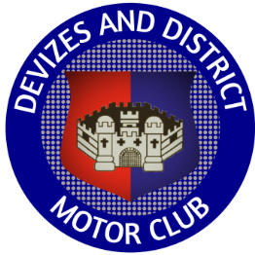

Devizes and District Motor Club

Valleys and Villages Classic Tour Sunday 4th August 2024

Any last minute amendments, and changes to the entry list, will be on the rallies info website.

If you have not already done so, please ‘sign on’ electronically through your competitor home entry page.

If you don’t have an accurate tripmeter, you might like to try the KCC Tripmeter app on your smartphone.

Order of the Day

Start and finish - Royal Wootton Bassett Rugby Football Club, 1.5m from Junction 16 of the M4 on the B4042, OS map 173 ref 070 841, what3words - atlas.activity.started

Follow arrow and marshal’s instructions for parking.

Club house opens at 08.30 where breakfast roll, tea, coffee and pastries will be available.

Collect road book, showground pass and rally plate to fix to front of car with cable ties supplied.

Cars will leave at one minute intervals from 09.31, so your start time will be 09.30 plus your car start number. All timings are for guidance only. It’s not a race!

(There is no official morning coffee halt which gives you longer at the showground).

Lunch Halt – Newbury Showground plenty of time for picnics, to purchase refreshments and look around the Classic Vehicle Show. Take care on entry as you will be driving through a pedestrian area.

The Rugby Club bar will be open at 15.30. Food will be served between 16.30 and 18.00

Please do not arrive back too early.

Enjoy the day and hope for sunshine, but bring an umbrella!

Urgent enquiries to Jill on 07778 911256

