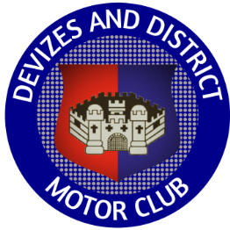

Devizes and District Motor Club

Valleys and Villages Classic Tour Sunday 3rd August 2025

You can find the entry list with your start number here

Valleys and Villages Tour 2025 - Online Entries

Any last minute amendments will be posted on the virtual notice board

If you have not already done so, please ‘sign on’ electronically using the Access your entry home page link on your original ‘entry received’ email.

If you don’t have an accurate tripmeter, you might like to try the KCC Tripmeter app on your smartphone.

Order of the Day

Start and finish - Royal Wootton Bassett Rugby Football Club, 1.5m from Junction 16 of the M4 on the B4042, OS map 173 ref 070 841, what3words - atlas.activity.started.

Follow arrow and marshal’s instructions for parking.

Club house opens at 09.00 and breakfast roll, tea, coffee and pastries will be available.

Collect road book, showground pass and rally plate to fix to front of car with cable ties supplied.

Cars will leave at one minute intervals from 10.01, so your start time will be 10.00 plus your car start number. All timings are for guidance only. It’s not a race!

There is no official morning coffee halt which gives you longer at the classic car show, however a couple of coffee venues are included in the roadbook if you wish to take a break and then spend less time at the show.

Lunch Halt – Newbury Showground plenty of time for picnics, to purchase refreshments and look around the Classic Vehicle Show. Take care on entry as you will be driving through a pedestrian area.

The Rugby Club bar will be open at 15.30. Food will be served between 16.30 and 18.00

Please do not arrive back before 15.30 as the car park gate will be locked.

Enjoy the day and hope for sunshine, but bring an umbrella!

Urgent enquiries to Jill on 07778 911256

